Week 6 results

Try to use read/write size instead of read/write number to show the performance on LASR trace.

Try to apply the algorithm on ALCF trace.

# Parameter settings:

Trace file: LASR trace and ALCF trace

Edge adding window: 10s

Edge expire window: 1 day

Update period: 1day

Using fixed ssd capacity ratio to control the data placement instead of using threshold.

Three metrics for placement:

1. Ratio of connections from SSD (Main metric):   
   number of connections with neighbors in SSD / number of connections with all neighbors
2. Accumulated access frequency:  
   number of access.

# Results:

Both of experiments have poor performance. But using accumulated access frequency is still better than using ratio of connections (graph based).

I have not draw the overall access, because if I draw them on the same figure, you can hardly see the access from SSD.

1. Performance comparison for LASR traces when using access size instead of access count

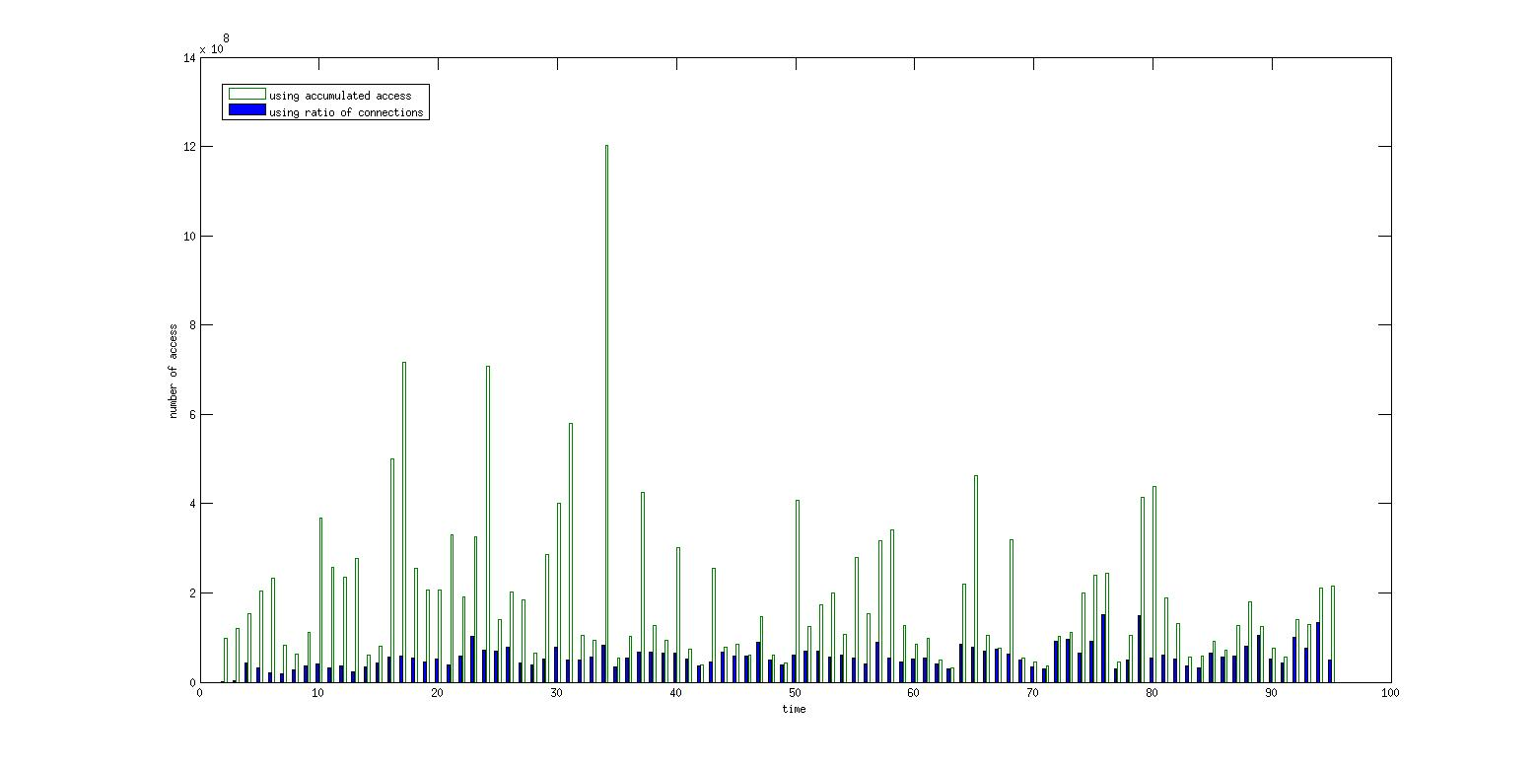

1. Performance comparison for ALCF traces

